# 3D MAT M2080 End Results

Project participants: Joona Räisänen, M2080

GitHub Repo Link: <https://github.com/jopoti/3DModeling.git>

## Project 1: Barrel

Figure A screenshot of the barrel in blender

Figure UV Unwrap of the barrel with seams and sharp edges visible

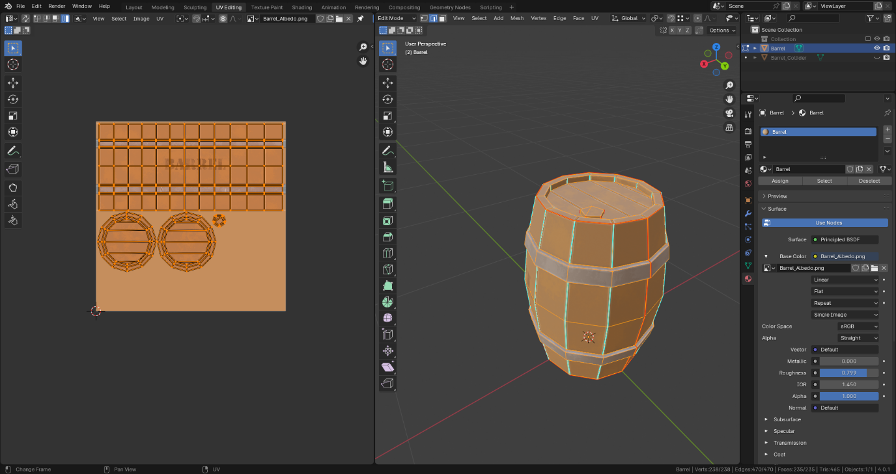

Figure : Material node setup in shader editor

Figure Barrel Meshes & Textures added to Unity and made into a prefab.

Figure Gimp setup for painting the textures.

### What did I do?

I made a barrel following a tutorial from LMHPOLY on YouTube. <https://www.youtube.com/watch?v=KFEb51rinwI&list=PLQk3p-aJsSWTKKmuFwnzEVaf3ovKIg1jx>

### What went right and what went wrong?

Not a lot went wrong with this one as this was the right amount of challenge for a complete beginner like me.

### What was difficult?

Learning blender in general and trying to memorize some of the shortcuts in blender. Also, I haven’t opened Unity in years.

### What did you learn?

I learned the basics of game asset creation pipeline. Modelling, UV unwrapping, Texturing in Gimp, Exporting the model into a game engine (Unity) & making a prefab in Unity.

### How much time did you spend making things?

Way too much for such a simple model. Maybe around 10 hours?

## Project 2: Mug

Figure A Render of the mug

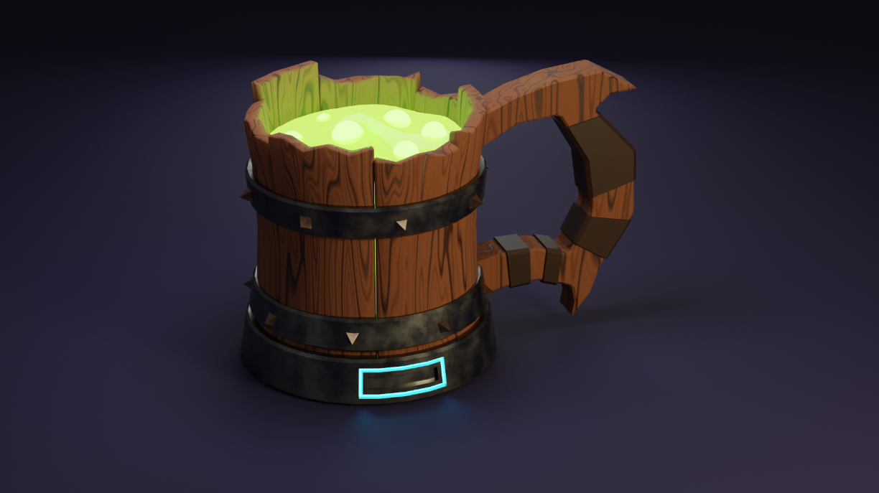

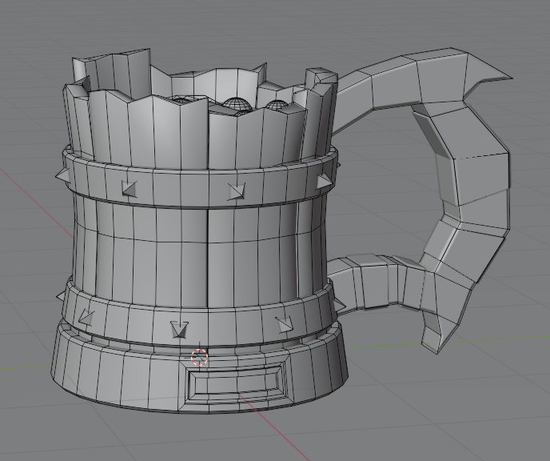

Figure Material Node setup for the potion inside the mug

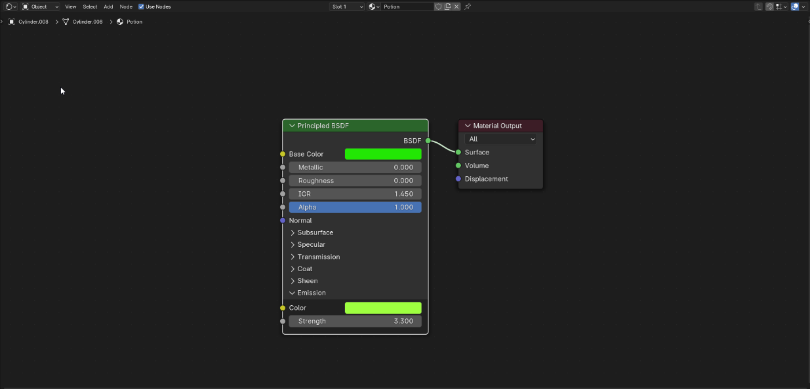

### What did I do?

I made a stylized mug containing a magic potion by following a tutorial from ChaaKoraa on YouTube.

Link to the tutorial video: <https://www.youtube.com/watch?v=taTUMvf98hc>

### What went right and what went wrong?

I like how the render turned out, but I am a bit lost on how to turn this into a functional game ready asset. I need to study more about UV unwrapping, texture baking and retopology.

### What was difficult?

Material nodes were a bit confusing at first and I need to study more to complete this model into a functional asset.

### What did you learn?

A bit more advanced modelling compared to the barrel and some handy shortcuts like Ctrl + Right click to extrude selection to mouse cursor or the shortcut for the bevel modifier Ctrl + Shift + B to round edges.

I also learned to use the Shader editor to create different materials for the model.

For the render I also learned to create a simple 3-point lighting setup.

### How much time did you spend making things?

Somewhere between 20-25 hours. (I’m just pulling these numbers out of my ass I can’t remember.)

## Project 3: Blunderbuss

Figure Model of blunderbuss.

Figure UV unwrap of the blunderbuss.

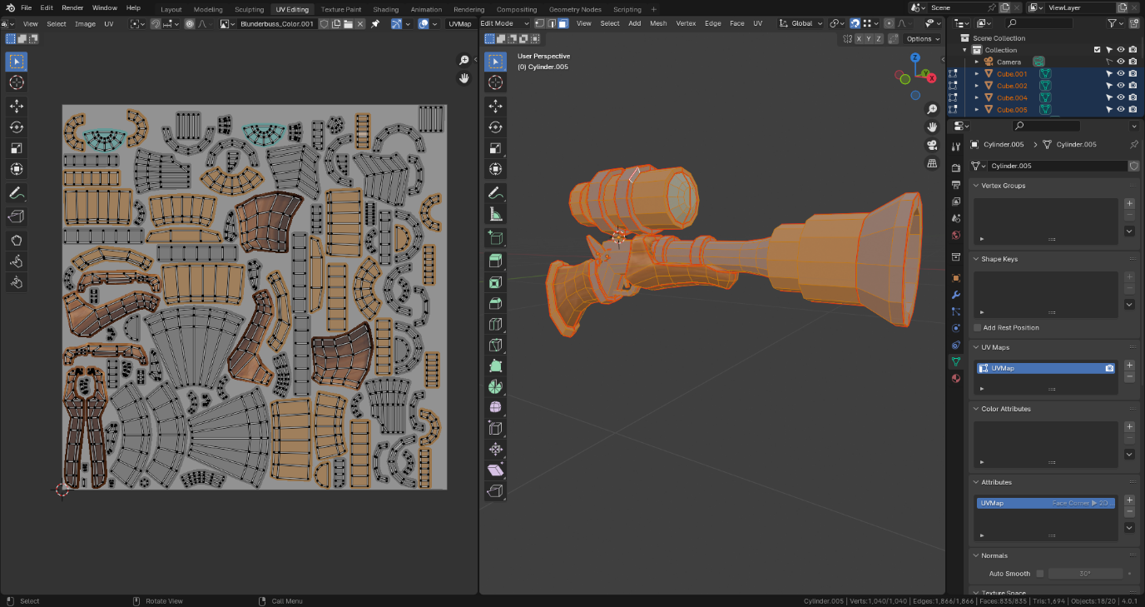

Figure Material node setup for the blunderbuss.

Figure Reference image for the blunderbuss.

### What did I do?

I made a low poly stylized model of a blunderbuss/ thunder gun following a tutorial from Grant Abbitt on YouTube.

Link to the video playlist: <https://www.youtube.com/watch?v=5oOHY7TM96c&list=PLn3ukorJv4vvkmo-mNOsicGj097lsS5-s>

### What went right and what went wrong?

It’s going alright so far; I had some trouble with the retopology as my model was not really one to one with the tutorial video and I had to figure out how to add and merge some vertices to make the model work. The UV unwrapping had me scratching my head as well but I’m getting there.

Also, the model is not finished yet!

### What was difficult?

Retopology and UV unwrapping were difficult and time consuming.

### What did you learn?

Using a reference image for modelling, Retopology, Using the knife tool, Merging and separating objects. More about UV unwrapping like how to correct stretching and Texture painting in Blender.

### How much time did you spend making things?

It’s not finished yet and I honestly have no Idea. I have clocked in 100+ hours of blender from the start of this course.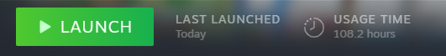

## Honourable mention: Axe

Figure The axe model

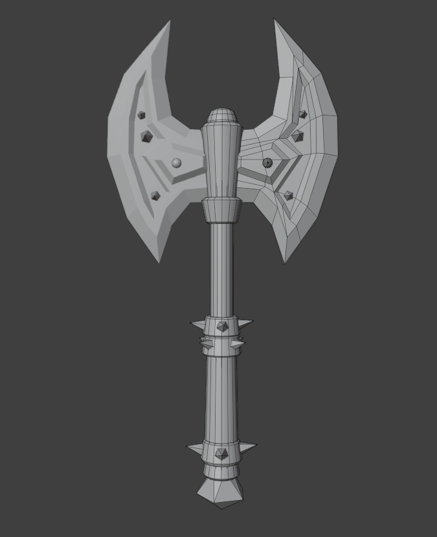

I also made this axe model also following a guide from ChaaKoraa. It’s only model at this point though and has no UV unwrap, Retopo or texturing done.